https://www.mirror.co.uk/news/politics/breaking-no10-admits-mistake-coronavirus-22968537?utm_source=twitter.com&utm_medium=social&utm_campaign=sharebar

No10 admits mistake in coronavirus forecasts used to justify England's lockdown
Slides presented at the Downing Street press conference predicting coronavirus deaths could hit 1,400 per day by December have been revised downwards.d80

Downing Street has admitted there were mistakes in coronavirus forecasts used by Boris Johnson to justify England's new lockdown.
Alarming slides shown at the No10 press conference on Saturday by Chief Scientific Adviser Sir Patrick Vallance predicting Covid deaths could hit 1,400 a day by early December have now been revised downwards.
The graph, based on forecasts by the Scientific Pandemic Influenza Group on Modelling, projected a top-end range of more than 1,400 deaths a day by December 8 - well above the first-wave peak of almost 1,000.
But on Tuesday, the slide was quietly reissued with the top-end range revised down to just over 1,000 deaths a day.
Another slide forecasting hospital admissions would reach nearly 9,000
at the top end has also been changed to just over 6,000 a day.
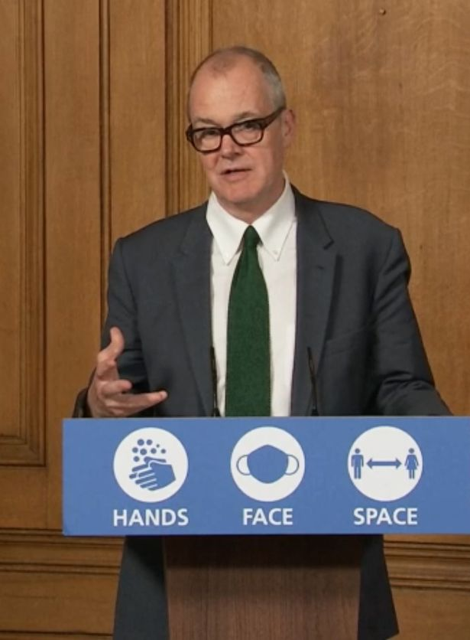
Sir Patrick Vallance has come under criticism over forecasts shown at the No10 press conference on Saturday (Image: PA)
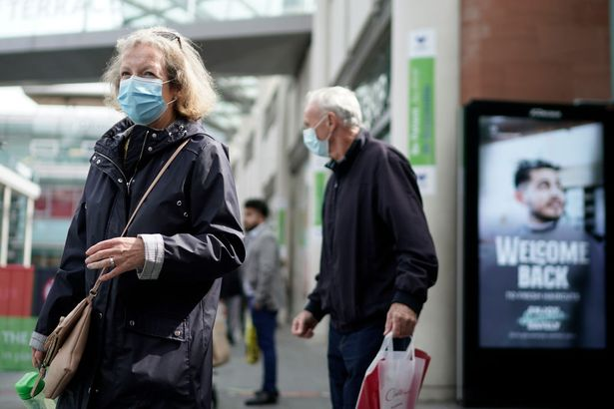
England was placed into a second national lockdown on Thursday (Image: Getty Images)
- 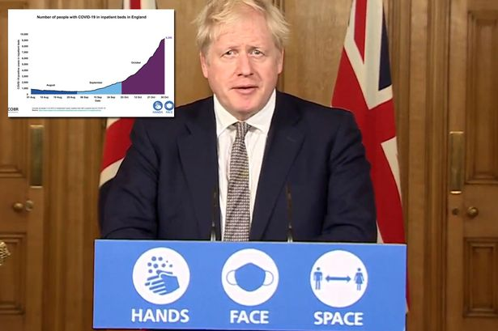Boris Johnson warns no lockdown would mean 'several thousand' coronavirus deaths a day
The central projections for daily hospital admissions was unchanged at just over 4,000 a day and the daily deaths remain the same at under 800.
A spokesman for the Prime Minister said the Government accepted there had been an error.
On the revised graphs, he said: "We accept there was a mistake in plotting the confidence intervals, which are the blue shaded areas, which we corrected as soon as identified, but there was no error in the underlying analysis."
Asked if this could undermine public confidence, the spokesman said: "There was a mistake in plotting the confidence intervals but the data still shows - and I would highlight that the consensus remains - that without action we would breach the first wave of hospital admissions and deaths in a matter of weeks.

"I would also point back to what the PM said yesterday about our desire to present data in as clear a way as possible."
Asked if the PM would apologise, the spokesman said the mistake had been acknowledged and the Government was committed to presenting data in a clear way.
He insisted Mr Johnson had confidence in the Chief Scientific Adviser.
It comes after the official statistics watchdog rebuked Sir Patrick over the Government's use of data the pandemic.
In a letter to the chief scientist, the Office for Statistics Regulation warned that the lack of transparency surrounding some of the figures meant there was "potential to confuse the public and undermine confidence in the statistics".
Professor Carl Heneghan, of Oxford University, tweeted: "The Government's use of data is not just confusing - the errors are positively misleading."
Business Minister Nadhim Zahawi said it was an "irrefutable" fact that hospital admissions are rising sharply and insisted the Government has to get the R number - representing the reproduction rate of the disease - down.

I take on board what the official statistics watchdog said. We will always try to improve our graphs and our presentations," he told Sky News.
"But, at the same time, the facts are very clear that we had to make this very difficult decision.
"I am certain that actually this decision is the right one but will also ultimately deliver what we all want to see, which is that reduction in the R number."

